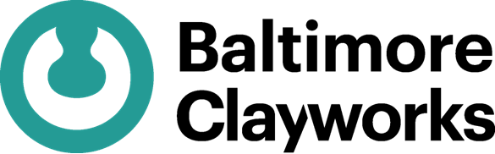

BALTIMORE CLAYWORKS LONG-TERM RESIDENCY APPLICATION

CONTACT INFORMATION

Name ________________________________________________________________________

Pronouns ________________________________________________________________________

Address_______________________________________________________________________

City _______________________________ State _________________ Zip _________________

Phone_____________________________ Email ______________________________________

LORMINA SALTER FELLOWSHIP (open to all applicants)
Please indicate your interest in consideration for the Lormina Salter Fellowship Y/N

EMBARC FELLOWSHIP (open to BIPOC Residents of MD)
Please indicate your interest in consideration for the EMBARC Fellowship Y/N

EDUCATIONAL BACKGROUND/EQUIVALENT EXPERIENCE 1

Year:

Degree/Major/Position:

School/Location:

EDUCATIONAL BACKGROUND/EQUIVALENT EXPERIENCE 2

Year:

Degree/Major/Position:

School/Location:

EDUCATIONAL BACKGROUND/EQUIVALENT EXPERIENCE 3

Year:

Degree/Major/Position:

School/Location:
THREE CONTACT REFERENCES

Name_________________________________________________________________________
Title/Organization______________________________________Phone____________________

Name_________________________________________________________________________
Title/Organization______________________________________Phone____________________

Name_________________________________________________________________________
Title/Organization______________________________________Phone____________________

MORE ABOUT YOURSELF
How did you hear about Baltimore Clayworks?

List any arts background/involvement. (i.e., memberships, arts events attended/supported, studies, subscriptions, etc.)

List any goals and other areas of interests that you would like to explore while at Baltimore Clayworks:

What other hobbies/skills/talents do you have? Do you have anything else that you would like us to know about yourself?
APPLICATION CHECKLIST
______Completed application form
______Letter of Intent/Project proposal
______Resume
______Artist statement
______10 images of work created within the last 3 years
______Image description sheet

EMAIL ALL APPLICATION MATERIALS TO submissions@baltimoreclayworks.org

Applications Due: April 1

There is NO FEE for application.

If you have any questions or need assistance preparing your application, please do not hesitate to contact Resident/Fellowship Coordinator via email at rebecca.morton@baltimoreclayworks.org or call 410-578-1919.

