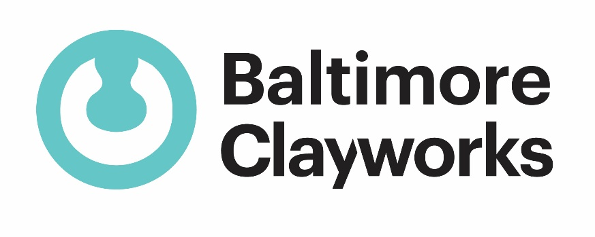
2022 BALTIMORE CLAYWORKS SHORT-TERM RESIDENCY APPLICATION

CONTACT INFORMATION

Name ________________________________________________________________________

Address_______________________________________________________________________

City _______________________________ State _________________ Zip _________________

Phone_____________________________ Email ______________________________________

EDUCATIONAL BACKGROUND 1

Year:

Degree/Major:

School:

EDUCATIONAL BACKGROUND 2

Year:

Degree/Major:

School:

EDUCATIONAL BACKGROUND 3

Year:

Degree/Major:

School:

TIME FRAME: Please select your top three choices by assigning them numerical values, #1 being your top choice.

FALL (Sep, Oct, Nov) WINTER (Dec, Jan, Feb)

SPRING (March, April, May) SUMMER ( June, July, Aug)

THREE CONTACT REFERENCES

Name_________________________________________________________________________
Title/Organization______________________________________Phone____________________

Name_________________________________________________________________________
Title/Organization______________________________________Phone____________________

Name_________________________________________________________________________
Title/Organization______________________________________Phone____________________

MORE ABOUT YOURSELF
How did you hear about Baltimore Clayworks?

List any arts background/involvement. (i.e., memberships, arts events attended/supported, studies, subscriptions, etc.)

List any goals and other areas of interests that you would like to explore while at Baltimore Clayworks:

What other hobbies/skills/talents do you have? Do you have anything else that you would like us to know about yourself?

APPLICATION CHECKLIST
______completed application form
______project proposal
______resume
______artist statement
______10 images of work created within the last 3 years
______image description sheet

SUBMIT ALL APPLICATION MATERIALS TO:

Applications Due: April 1

There is NO FEE for application.

If you have any questions or need assistance preparing your application, please do not hesitate to contact Resident/Fellowship Coordinator via email at kevin.rohde@baltimoreclayworks.org or call 410-578-1919.

